**St. Francis Institute of Technology Borivli (West), Mumbai-400103**

**(Autonomous Institute)**

**Department of Information Technology**

**Sub: Internet Programming**

**Experiment – 1**

**1. Aim:** To design a personal profile (One page) using HTML-5 and CSS **2. Objective:** To explore use of HTML-5 and CSS markup languages for web designing.

**3. Lab outcome:** After performing the experiment, the students will be able to **design and develop** a web page and view it in the web browser.

**4. Prerequisite:**

• Fundamental knowledge of HTML and CSS

• Familiarity with the web browsers

**5. Requirements:** The following are the hardware and software requirements **–** PC with windows OS Notepad, Google Chrome etc.

**6. Pre-Experiment Theory:**

**What is HTML-5?**

HTML (Hyper Text Markup Language) is a markup language used to create web page documents. It is a markup language used by web browsers to visualize code. HTML-5 is 5th version of HTML that features se veral improvements in website capabilities, and web content development. HTML5 features include markup and scripting elements, as well as application programming interfaces (APIs) for functionalities such as adding video and audio on a page, local data storage, offline operations, and location data usage. With HTML5 addressing standard web development functions, dev teams don’t need to create functionality from scratch for every application and can instead rely on built-in browser capabilities.

For details of various HTML elements, refer to web page https://www.w3schools.com/tags/

**What is CSS?**

CSS (Cascading style sheets) describe to the user how to display HTML elements on the screen in a proper format. It is the markup language that is used to style HTML documents. With the help of CSS, we can change the colour of text, we can change the style of fonts, and we can control the spacing between the paragraph etc.. CSS is easy to understand and provides strong control on the Html documents.CSS is used along with HTML. CSS selectors are used to find (or select) the HTML elements you want to style.

**7. Laboratory Exercise**

**A. Steps to be implemented.**

Follow the procedure given below to design a web page to display your single page resume 1. Choose a template for resume design. Refer to reference – 1 given below.

2. Open a notepad or any other text editor or visual studio code.

3. Open a new file and write HTML code using its elements to design a web page to display resume as per chosen template.

4. Save file as .html

5. Style the resume using CSS markup language.

6. To view the output, right click the file and select open with option.

7. Test your resume web page in different browsers such as Google Chrome, Microsoft Edge or OPERA etc.

**1 | Internet Programming Lab**

**B. Program Code**

1. Write a program code using HTML-5 and CSS markup languages, to design a web page to display a single page resume of your own. For templates of a single page resume, refer to the first reference given below.

Following is the suggestive list of components of your profile page

• Your photograph

• About you (Some inspirational quote)

• Personal details (Name, Address, email, phone)

• Academic qualifications

• Skills

• Projects

• Internships

• Hobbies

• Achievements

**8. Post Experimental Exercise**

**C. Questions:**

1. Differentiate between HTML and HTML-5

2. Convert your single page resume, designed in this experiment, to pdf file to upload to LinkedIn.

**D. Results/Observations/Program output:**

Present the program input/output results if any and comment on the same.

**E. Conclusion:**

1. Write what was performed in the experiment.

2. Write which tools you used to perform the experiment

3. Write what you inferred from the output obtained.

**F. References:**

[1] https://novoresume.com/career-blog/one-page-resume

[2] https://veerasundar.com/blog/how-to-make-resume-in-html-export-to-pdf [3] https://medium.com/@iftimiealexandru/creating-a-resume-using-html-and-css and-saving-it-as-a-pdf-e85d24b0408e

[4] https://steemit.com/steemstem/@gotgame/how-to-create-a-one-page-resume website-using-html-css-flat-design

[5] https://github.com/imvpn22/resume

[6] <https://codepen.io/DeepS/pen/DLyZam>

**2 |Internet Programming Lab**

**B. Program Code**

1. Write a program code using HTML-5 and CSS markup languages, to design a web page to display a single page resume of your own.

**HTML CODE:**

**<!DOCTYPE html>**

**<html lang="en">**

**<head>**

**<meta charset="UTF-8">**

**<meta name="viewport" content="width=device-width, initial-scale=1.0">**

**<title>Durva Kadam - Resume</title>**

**<link rel="stylesheet" href="ip.css">**

**</head>**

**<body>**

**<div class="container">**

**<div class="header">**

**<div class="about">**

**<h1>DURVA KADAM</h1>**

**<p>I am a highly organized and dependable candidate successful at managing multiple priorities with a positive attitude. Willingness to take on additional responsibilities to achieve team goals.</p>**

**</div>**

**<div class="profile-pic">**

**<img src="photo_durva1.jpeg" alt="Profile Picture">**

**</div>**

**</div>**

**<div class="main-content">**

**<div class="left-side">**

**<div class="contact-info">**

**<p><a href="mailto:durvakadam204@gmail.com">durvakadam204@gmail.com</a><br>8828174914</p>**

**<p>Borivali(E), Mumbai 400066</p>**

**<p><a href="https://www.linkedin.com/in/durva-kadam-02a22a25a">LinkedIn</a> | <a href="https://github.com/durvaakadam">GitHub</a></p>**

**</div>**

**<div class="section skills">**

**<div class="section-title">Skills</div>**

**<ul>**

**<li>Python</li>**

**<li>Java</li>**

**<li>C</li>**

**<li>C++</li>**

**<li>SQL</li>**

**<li>HTML</li>**

**<li>CSS</li>**

**<li>Decision making</li>**

**<li>Dependable and Responsible</li>**

**<li>Written Communication</li>**

**<li>Verbally Outspoken</li>**

**</ul>**

**</div>**

**<div class="section hobbies">**

**<div class="section-title">Hobbies</div>**

**<ul>**

**<li>Reading</li>**

**<li>Learning languages</li>**

**<li>Music</li>**

**</ul>**

**</div>**

**</div>**

**<div class="right-side">**

**<div class="section education">**

**<div class="section-title">Education</div>**

**<ul>**

**<li>St. Xavier’s High School, 2020</li>**

**<li>Don Bosco Jr. College, 2022</li>**

**</ul>**

**</div>**

**<div class="section experience">**

**<div class="section-title">Work Experience</div>**

**<ul>**

**<li>NSS, Information Technology Students Association (finance executive)</li>**

**<li>Alumni Association (events & logistics executive)</li>**

**<li>National Scout and Guide Association (3 camps attended with certificates)</li>**

**</ul>**

**</div>**

**<div class="section projects">**

**<div class="section-title">Projects</div>**

**<ul>**

**<li><strong>Quizzard</strong>: A quiz-based attendance system application which takes real-time attendance using quizzes. It helps enhance administrative efficiency and student participation.</li>**

**<li><strong>Pizza Mania</strong>: This project aimed at order management, real-time inventory control, menu customization, etc., along with a visually appealing GUI.</li>**

**</ul>**

**</div>**

**<div class="section participation">**

**<div class="section-title">Participation</div>**

**<ul>**

**<li>Volunteer for Rekindle</li>**

**<li>Participant in COLLOQUIUM '24</li>**

**<li>Participated in MOSAIC '24</li>**

**</ul>**

**</div>**

**</div>**

**</div>**

**</div>**

**</body>**

**</html>**

This HTML code creates a personal resume web page for Durva Kadam. The page is structured using HTML5 elements and styled with an external CSS file (ip.css). It includes sections for personal details, skills, hobbies, education, work experience, projects, and participation. The layout features a header with a profile picture and a main content area divided into left and right sides, each containing relevant information. Links to email, LinkedIn, and GitHub profiles are also provided.

**CSS CODE:**

**body {**

**font-family: Arial, sans-serif;**

**margin: 0;**

**padding: 0;**

**background-color: #f4f4f4;**

**}**

**.container {**

**width: 100%;**

**max-width: 800px;**

**margin: 20px auto;**

**padding: 20px;**

**background-color: #fff;**

**box-shadow: 0 0 10px rgba(0, 0, 0, 0.1);**

**}**

**.header {**

**background-color: #de8ab8;**

**color: #fff;**

**padding: 20px;**

**border-radius: 8px 8px 0 0;**

**display: flex;**

**align-items: center;**

**justify-content: space-between;**

**}**

**.header h1 {**

**margin: 0;**

**font-size: 40px;**

**}**

**.profile-pic {**

**border-radius: 0%;**

**width: 350px;**

**height: 150px;**

**background-color: #fff;**

**overflow: hidden;**

**display: flex;**

**align-items: center;**

**justify-content: center;**

**}**

**.profile-pic img {**

**width: 100%;**

**height: auto;**

**}**

**.main-content {**

**display: flex;**

**}**

**.left-side, .right-side {**

**width: 50%;**

**padding: 10px;**

**}**

**.contact-info a {**

**color: #4CAF50;**

**text-decoration: none;**

**}**

**.section-title {**

**background-color: #4CAF50;**

**color: #fff;**

**padding: 10px;**

**margin-bottom: 10px;**

**font-weight: bold;**

**border-radius: 4px;**

**}**

**.skills, .education, .experience, .projects, .hobbies, .participation {**

**padding: 10px;**

**}**

**.skills ul, .education ul, .experience ul, .projects ul, .hobbies ul, .participation ul {**

**list-style-type: none;**

**padding: 0;**

**}**

**.skills ul li, .education ul li, .experience ul li, .projects ul li, .hobbies ul li, .participation ul li {**

**margin-bottom: 10px;**

**}**

**.skills ul li::before, .hobbies ul li::before, .participation ul li::before {**

**content: "•";**

**color: #4CAF50;**

**font-weight: bold;**

**display: inline-block;**

**width: 1em;**

**margin-left: -1em;**

**}**

This CSS code styles the personal resume web page for Durva Kadam. It sets the font to Arial and applies a light gray background to the body. The main container is centered with a white background, padding, and a subtle box shadow.

**RESUME:**

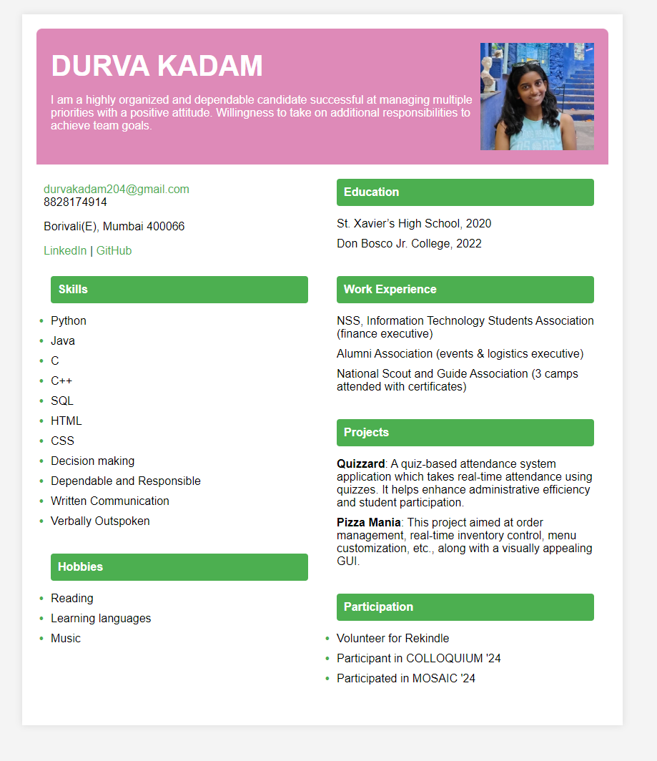

This is the final resume created using HTML5 and CSS. The layout is clean and visually appealing, with distinct sections for personal details, skills, projects, and more. It effectively highlights qualifications and involvement in various activities, making it easy for potential employers.